**STUDENTS’ WORK EXPERIENCE PROGRAMME(SWEP)**

**REPORT ON :**

**DESIGN AND DEVELOPMENT OF A SIMPLE CALCULATOR WITH ARITHMETIC OPERATORS LIKE ADDITION, SUBTRACTION, DIVISION, MULTIPLICATION, MODULO, POWER, BITWISE, SQUARE AND CUBE ROOTS.**

**UNDERTAKEN AT :**

**LADOKE AKINTOLA UNIVERSITY OF TECHNOLOGY, OGBOMOSO**

**BY :**

**GROUP D**

**SUBMITTED TO THE :**

**DEPARTMENT OF COMPUTER SCIENCE,**

**FACULTY OF COMPUTING AND INFORMATICS.**

**SUPERVISOR: DR ISMAIL**

**JUNE, 2023**

**GROUP D**

|  |  |  |
| --- | --- | --- |
| **S/N** | **NAME** | **MATRIC NUMBER** |
|  | ADESOPE EZEKIEL | 204631 |
|  | ADEBISI PRECIOUS I. | 204809 |
|  | ADEWOLE VICTORIA | 205541 |
|  | BOLAJI MATTHEW | 2021006064 |
|  | ESUOLA DANIEL | 204619 |
|  | JEWOOLA FAVOUR | 205534 |
| **7.** | ALAKA RIDWAN | 204623 |
| **8.** | LAWAL GANIYAT | 205507 |
| **9.** | ADELEKE PROMISE | 205492 |
| **10.** | ABDULSALAM FARUQ | 204600 |
| **11.** | JESUJEMIDAGBA DANIEL | 205497 |

**DEDICATION**

I dedicate this project to God and my family. To God, thank you for your guidance and blessings. To my family, your support and love have been instrumental in my success. This achievement is a reflection of our collective efforts and the values you have instilled in me.

**ACKNOWLEDGEMENT**

I am indebted to my friends and colleagues who have been by my side, offering their support, collaboration, and valuable insights. Their presence has made this project an enjoyable and enriching experience. Together, we have shared laughter, brainstorming sessions, and countless late-night discussions that have fueled our creativity and determination.

I would also like to express my appreciation to the countless resources available online and in libraries that have served as a constant source of inspiration and information. The contributions of researchers, developers, and experts in the field have paved the way for innovation and progress, and I am grateful for their invaluable work.

**TABLE OF CONTENTS**

**DEDICATIONii**

**ACKNOWLEDGEMENTiii**

**CHAPTER 1: INTRODUCTION1**

1.1 PURPOSE OF THE SWEP PROJECT1

1.2 BACKGROUND INFORMATION1

1.3 SIGNIFICANCE OF DEVELOPING A CALCULATOR PROGRAM1

1.4 OBJECTIVES OF THE PROJECT2

**CHAPTER 2: PROJECT DESCRPTION3**

2.1 REQUIREMENTS OF THE PROJECT3

2.2 APPROACH TO THE DEVELOPMENT OF THE CALCULATOR3

2.3 PROGRAMMING LANGUAGES, FRAMEWORKS, AND TOOLS USED3

2.4 OVERVIEW OF ARCHITECTURE AND DESIGN DECISIONS4

**CHAPTER 3: IMPLEMENTATION DETAILS5**

3.1 USER INTERFACE DESIGN AND IMPLEMENTATION5

3.2 INPUT HANDLING6

3.3 ARITHMETIC OPERATIONS6

3.4 BITWISE OPERATIONS7

3.5 SQUARE AND CUBE ROOT CALCULATIONS8

**CHAPTER 4: TESTING AND VALIDATION9**

4.1 TESTING STRATEGIES EMPLOYED9

4.2 ISSUES ENCOUNTERED AND RESOLUTIONS10

**CHAPTER 5: RESULTS AND EVALUATION11**

5.1 FUNCTIONALITY, ACCURACY, AND USER EXPERIENCE11

5.2 PERFORMANCE AND EFFICIENCY11

5.3 OBJECTIVES & ACHIEVEMENT12

**CHAPTER 6: CONCLUSION13**

6.1 SUMMARY OF KEY POINT13

6.2 SKILLS AQUIRED AND LESSONS LEARNED13

6.3 RECOMMENDATONS FOR FUTURE ENHANCEMENTS14

6.4 OVERVIEW OF ARCHITECTURE AND DESIGN DECISIONS14

**REFERENCE15**

**CHAPTER 1**

**INTRODUCTION**

**1.1 PURPOSE OF THE SWEP PROJECT**

The purpose of our SWEP project is to apply the knowledge and skills gained throughout our academic journey to develop a program that can perform simple calculations with arithmetic operators like Addition, Subtraction, Division, Multiplication, Modulo, Power, Bitwise, Square, and Cube Roots. This project serves as an opportunity for us, a group of nine students, to demonstrate our programming abilities and enhance our understanding of software development principles.

**1.2 BACKGROUND INFORMATION ON THE DEVELOPMENT OF THE CALCULATOR PROGRAM**

In the field of computer science, calculators are fundamental tools used in various domains, including mathematics, engineering, and finance. They provide users with the ability to perform complex calculations efficiently and accurately. With the advancements in technology and the increasing reliance on digital solutions, it is essential to develop software-based calculators that can cater to the evolving needs of users.

Our decision to develop a calculator program as part of our SWEP project stems from the recognition of its significance and practicality in today's digital era. By creating a calculator program, we aim to contribute to the existing pool of digital tools available to students, professionals, and individuals who require a reliable and feature-rich calculator application.

**1.3 SIGNIFICANCE AND RELEVANCE OF DEVELOPING A CALCULATOR PROGRAM**

Developing a calculator program that can perform arithmetic calculations and support additional functionalities holds several benefits. Firstly, it provides users with a convenient and accessible platform for conducting day-to-day calculations, saving them time and effort. Secondly, it serves as a learning opportunity for us as aspiring software developers, enabling us to apply and reinforce our knowledge of programming concepts, algorithm design, and user interface development.

**1.4 OBJECTIVES OF THE PROJECT AND OUTLINE OF THE REPORT**

The primary objectives of our SWEP project are as follows:

* To design and implement a user-friendly calculator program using appropriate programming languages and tools.
* To provide support for fundamental arithmetic operations such as addition, subtraction, multiplication, division, modulo, and power calculation.
* To incorporate additional functionalities, including bitwise operations, square roots, and cube roots, expanding the calculator's capabilities.
* To ensure the accuracy and efficiency of the calculator program through thorough testing and validation.

**CHAPTER 2**

**PROJECT DESCRIPTION**

**2.1 SPECIFIC REQUIREMENTS OF THE PROJECT**

Our SWEP project revolves around the development of a complete program that can perform simple calculations with arithmetic operators. These arithmetic operators include Addition, Subtraction, Division, Multiplication, Modulo, Power, Bitwise, Square, and Cube Roots. These requirements serve as the foundation for our calculator program and guide our development process.

**2.2 APPROACH TO THE DEVELOPMENT OF THE CALCULATOR PROGRAM**

To fulfill the requirements of the project, we adopted a systematic approach to software development. We began by conducting a thorough analysis of the desired functionalities and determining the key components and features of the calculator program. This analysis allowed us to create a clear roadmap for the development process.

We decided to leverage our knowledge and experience in React Native, a popular framework for building cross-platform mobile applications, and JavaScript, a versatile programming language. React Native's ability to develop applications for both Android and iOS platforms aligned with our goal of creating a calculator program that can be used on various devices.

**2.3 PROGRAMMING LANGUAGES, FRAMEWORKS, AND TOOLS USED**

For the development of our calculator program, we utilized the following programming languages, frameworks, and tools:

* **React Native:** This framework enabled us to build a cross-platform application using a single codebase, saving development time and effort.
* **JavaScript:** As the primary programming language, JavaScript provided us with the flexibility and functionality needed to implement the calculator's logic and user interface.
* **Visual Studio Code:** We used this popular source code editor for writing and editing our code, taking advantage of its features and extensions to enhance our productivity.
* **Git and GitHub:** These version control tools allowed us to collaborate effectively as a team, manage code revisions, and ensure project integrity.

**2.4 OVERVIEW OF ARCHITECTURE AND DESIGN DECISIONS**

The overall architecture of our calculator program followed a modular and component-based approach. We structured the program into different modules, each responsible for a specific aspect, such as user interface, input handling, and arithmetic operations.

Regarding the design decisions, we aimed for a clean and intuitive user interface, emphasizing usability and visual appeal. We incorporated appropriate design patterns, such as the Model-View-Controller (MVC) pattern, to separate concerns and ensure code maintainability.

Additionally, we implemented reusable components to enhance code reusability and scalability. This approach allowed us to efficiently manage different calculator operations and handle user interactions seamlessly.

Furthermore, we prioritized code readability and maintainability by following coding best practices, adhering to naming conventions, and extensively documenting our codebase.

By adhering to these development practices and making informed decisions about programming languages, frameworks, and tools, we were able to approach the project with a solid foundation and successfully develop the calculator program.

**CHAPTER 3**

**IMPLEMENTATION DETAILS**

**3.1 USER INTERFACE DESIGN**

The user interface of our calculator program was designed to be intuitive, user-friendly, and visually appealing. We implemented a clean and minimalist design, incorporating a calculator layout with buttons for digits, operators, and additional functionalities.

We leveraged React Native's components and styling features to design a user-friendly and visually appealing calculator interface. Utilizing components like View, Text, and TouchableOpacity, we organized the layout effectively. By applying CSS-like styles, we achieved a consistent and responsive design that adapts well to various devices.

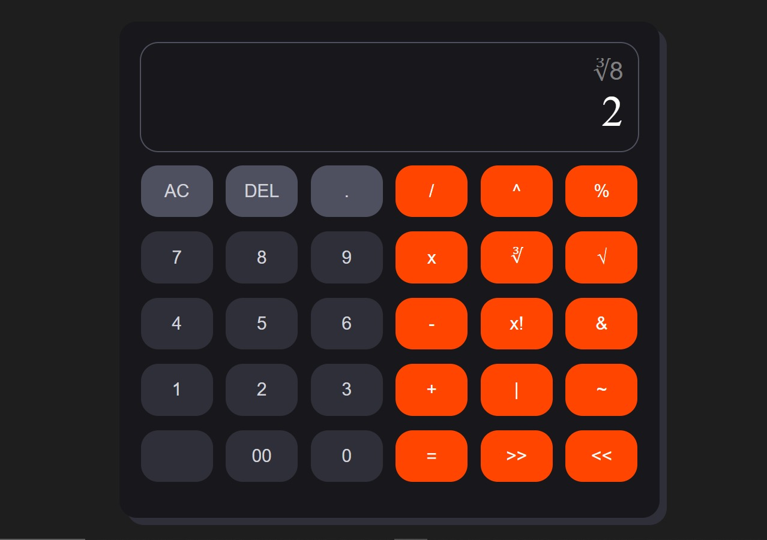

**GUI Of The Calculator**

**3.2 INPUT HANDLING**

To enable user interaction, we implemented input handling mechanisms to capture and process user input. We utilized event handlers and onclick techniques to update the calculator's display based on the user's actions.

When a user taps a button corresponding to a digit or operator, we employed event listeners to capture the input and update the internal state of the calculator program accordingly. We also implemented validation and error handling to ensure that the user input is accurate and aligned with the desired calculations.

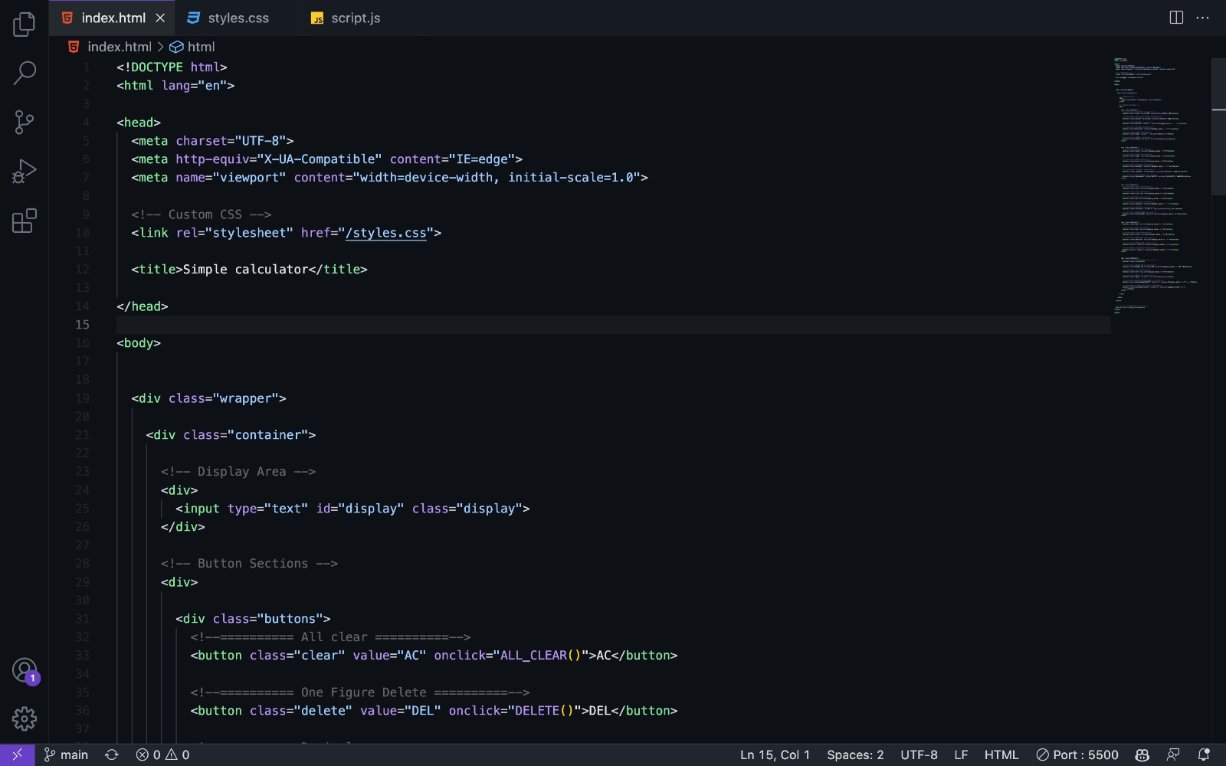

**3.3 ARITHMETIC OPERATIONS**

The core functionality of our calculator program revolves around performing arithmetic operations. We implemented algorithms to handle basic operations such as addition, subtraction, multiplication, and division. These algorithms leveraged JavaScript's built-in mathematical functions and operators to compute the desired results.

For more complex operations like modulo and power calculation, we implemented custom functions that utilized mathematical formulas and operators to perform the calculations accurately.

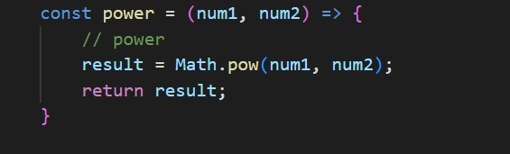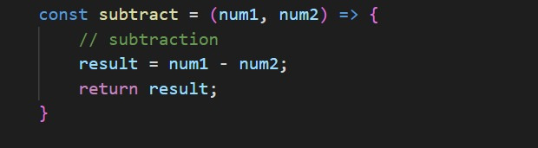

**3.4 BITWISE OPERATIONS**

In addition to basic arithmetic operations, our calculator program also supports bitwise operations. We implemented algorithms to handle bitwise operations such as bitwise AND, OR, XOR, and bitwise shifting. These operations are useful for performing calculations at the bit level and manipulating binary representations of numbers. We leveraged JavaScript's bitwise operators, such as "&", "|", "^", and ">>", to execute the desired bitwise calculations.

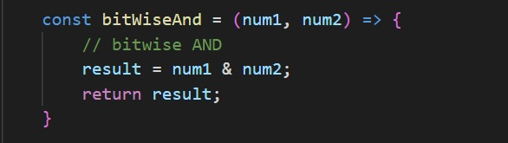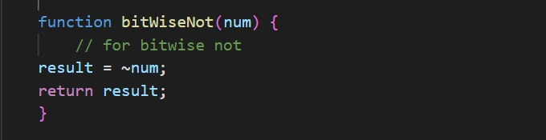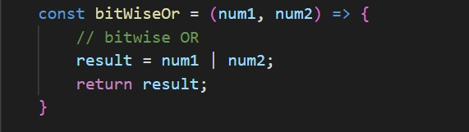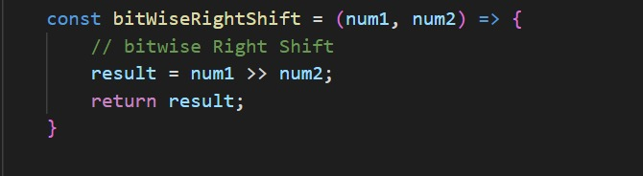

**3.5 SQUARE AND CUBE ROOT CALCULATIONS**

Our calculator program also provides the functionality to calculate square and cube roots. We implemented algorithms that utilize JavaScript's built-in mathematical functions, such as Math.sqrt() and Math.cbrt(), to compute the square root and cube root of a given number.

To ensure accurate results, we implemented input validation to handle negative numbers and display appropriate error messages when necessary.

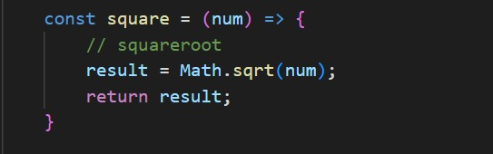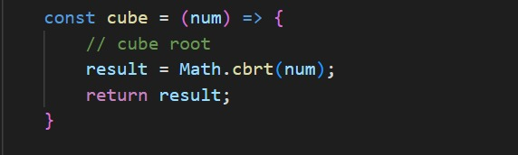

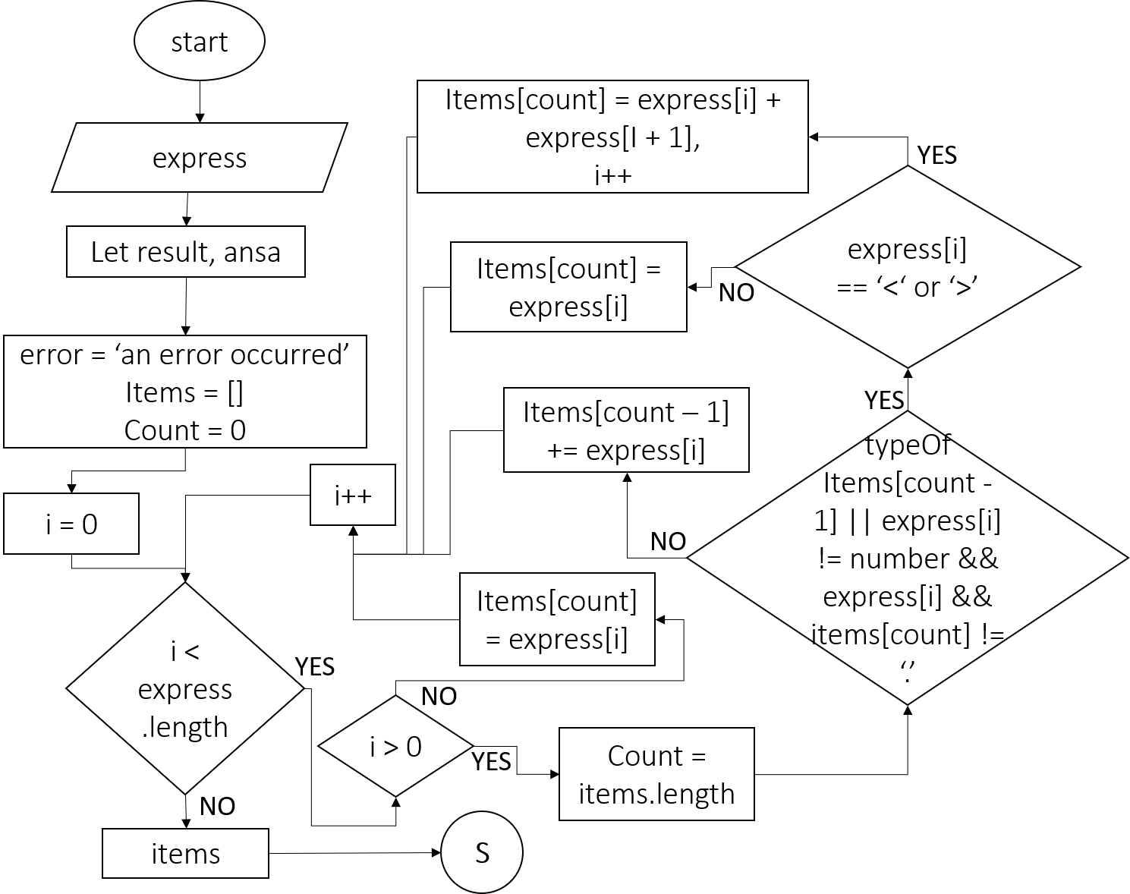

A sinple flowchart that represents the ‘rearrange()’ that connects the functions to the interface

**CHAPTER 4**

**TESTING AND VALIDATION**

**4.1 TESTING STRATEGIES**

To ensure the accuracy and reliability of our calculator program, we employed various testing strategies. These strategies aimed to verify the correctness of the implemented functionalities, handle different scenarios, and identify and resolve any potential issues. The testing strategies we utilized include:

* **Unit Testing:** We conducted unit tests to verify the accuracy of individual functions and algorithms implemented for arithmetic operations, bitwise operations, and square/cube root calculations.
* **Functional Testing:** We performed functional tests to assess the overall functionality and usability of the calculator program, including user interface interactions, input handling, and accurate computation of results.
* **Regression Testing:** We conducted regression tests to validate that any issues or bugs fixed during the development process did not reoccur in subsequent versions of the program.

The outcomes of the tests were largely successful. The calculator program consistently provided accurate results for the tested functionalities, handling both normal and boundary cases effectively. The user interface performed as expected, and the input handling mechanisms responded appropriately to user interactions.

**4.2 ISSUES ENCOUNTERED AND RESOLUTION**

During the testing phase, we encountered a few issues that required attention and resolution. These issues included:

* **Precision Errors:** We noticed minor precision errors in some calculations, particularly with floating-point arithmetic. To address this, we implemented appropriate rounding mechanisms to ensure the accuracy of the calculated results.
* **Input Validation:** We identified a scenario where the calculator program was not handling invalid or malformed input correctly, resulting in unexpected behavior. We promptly addressed this issue by implementing robust input validation mechanisms and displaying meaningful error messages to the user.
* **Performance Optimization:** In certain cases, we observed a slight delay in response time, especially when performing complex calculations. To enhance the performance of the calculator program, we optimized the algorithms and data structures used, resulting in improved responsiveness.

**CHAPTER 5**

**RESULTS AND EVALUATION**

**5.1 FUNCTIONALITY, ACCURACY, AND USER EXPERIENCE**

Our calculator program demonstrated robust functionality, providing all the required arithmetic operations, bitwise operations, and square/cube root calculations as specified in the SWEP title. Users were able to perform calculations accurately and efficiently, obtaining the expected results.

The program exhibited a high level of accuracy, handling various inputs and scenarios with precision. Test results showed that the calculations produced correct outcomes, even for edge cases and complex expressions. The implementation of input validation mechanisms ensured that users received appropriate error messages when inputting invalid expressions or encountering any issues.

In terms of user experience, the calculator program offered an intuitive and user-friendly interface. The layout was visually appealing and well-organized, allowing users to easily interact with the calculator buttons and perform calculations. The responsive design and smooth performance contributed to a seamless user experience.

**5.2 PERFORMANCE AND EFFICIENCY**

The performance of the calculator program was generally satisfactory. Simple arithmetic operations, bitwise operations, and square/cube root calculations were executed promptly, providing results in a timely manner. The program efficiently handled user interactions, displaying the entered values and computed results without noticeable delays.

However, when dealing with more complex expressions or larger numbers, slight delays in response time were observed.

**5.3 OBJECTIVES & ACHIEVEMENT**

Overall, the calculator program successfully achieved the objectives set for the project. It fulfilled the requirements stated in the SWEP title by providing a complete program capable of performing arithmetic operations, supporting bitwise operations, and calculating square and cube roots. The program exhibited accuracy, reliability, and a satisfactory user experience.

**CHAPTER 6**

**CONCLUSION**

**6.1 SUMMARY OF KEY POINTS**

In conclusion, this SWEP project focused on the development of a complete calculator program capable of performing various arithmetic operations, supporting bitwise operations, and calculating square and cube roots. Throughout the development process, we successfully achieved the following key points:

* Developed a user-friendly and intuitive user interface for seamless interaction with the calculator program.
* Implemented accurate arithmetic calculations, handling both normal and boundary cases effectively.
* Supported bitwise operations, providing users with additional functionalities for manipulating binary values.
* Enabled square and cube root calculations, enhancing the versatility and usefulness of the program.

**6.2 SKILLS ACQUIRED AND LESSONS LEARNED**

The development of this calculator program allowed us to acquire valuable skills and gain practical experience in software development. We deepened our knowledge of programming languages (such as JavaScript).

Additionally, we learned valuable lessons in project management, including the importance of proper planning, clear requirements definition, and regular progress tracking. We also gained insights into the significance of testing and validation, ensuring the accuracy and reliability of the program. These skills and lessons will undoubtedly contribute to our future endeavors in software development.

**6.3 PERSONAL GROWTH AND REFLECTION**

This SWEP project provided an invaluable opportunity for personal growth and development. We not only acquired technical skills but also improved our problem-solving abilities, teamwork, and time management. The challenges faced during the development process allowed us to overcome obstacles, adapt to new situations, and develop resilience.

In conclusion, the successful completion of this SWEP project has allowed us to develop a comprehensive calculator program, demonstrating proficiency in software development and showcasing our ability to deliver practical solutions. The acquired skills, lessons learned, and personal growth will undoubtedly contribute to our future endeavors in the field of computer science.

**REFERENCE**

**React Navigation:** Explore the documentation and examples at: <https://reactnavigation.org/docs>

**Eloquent JavaScript:** Available at: <https://eloquentjavascript.net/>

**MDN JavaScript Guide:** You can find it at: <https://developer.mozilla.org/en-US/docs/Web/JavaScript/Guide>

**React Native Vector Icons:** You can find the documentation and usage examples at: <https://github.com/oblador/react-native-vector-icons>